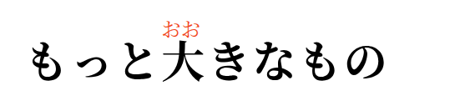
2028-08-24 Mitsue


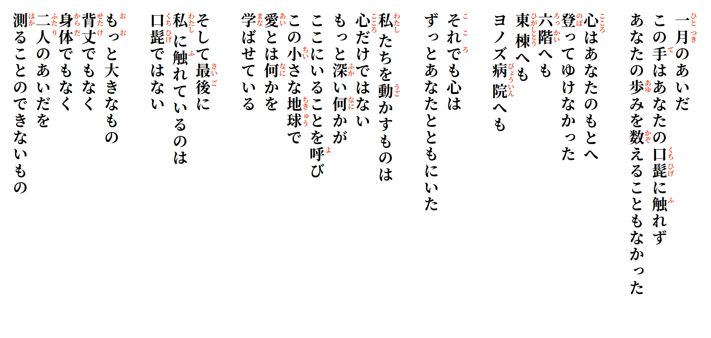
It is something much bigger—
something neither height
nor flesh
can ever measure
between the two of us.
And in the end,
it is not your mustache
that touches me.
What makes us move
is not the heart alone.
Something deeper calls us
to remain here,
on this small Earth,
learning what love
really is.
Yet my heart
was always there with you.
My heart could not climb to you—
not to the sixth floor,
not to the east wing,
not to Yonozu Hospital.
For a month, my hands
did not touch your mustache,
did not count your steps.

